**LAB 1 – AWS ELB**

**Task 1 - Webserver 1 IIS**

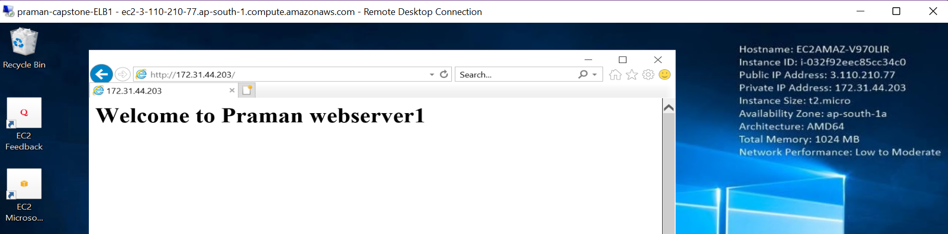

**Task 2 - AMI**

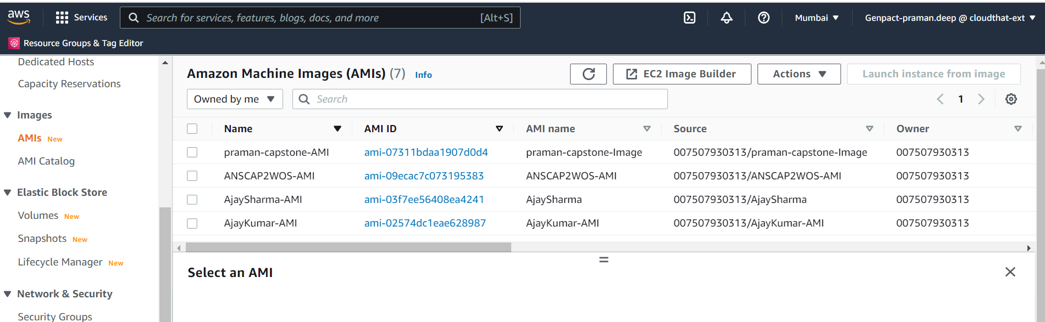

**Webserver 2 IIS via AMI**

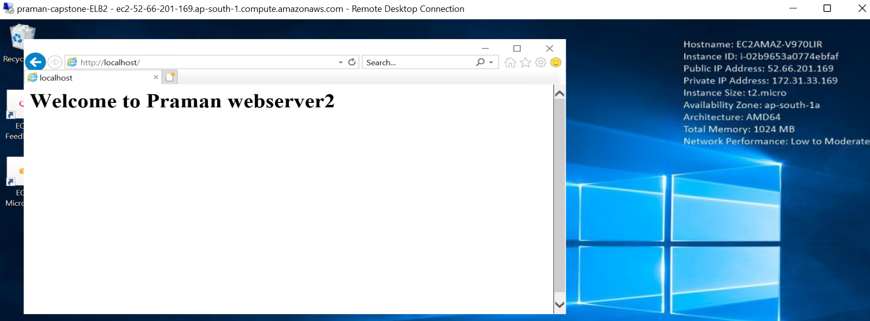

**Task 3 – ALB**

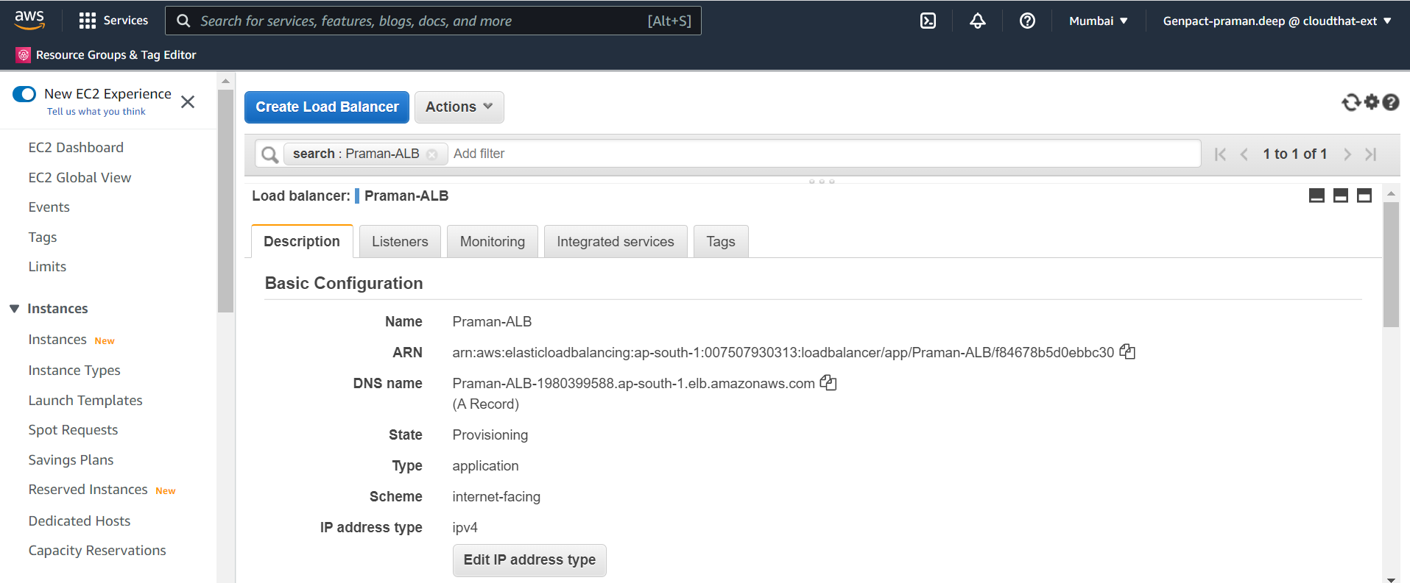

**Task 4 – Target Group**

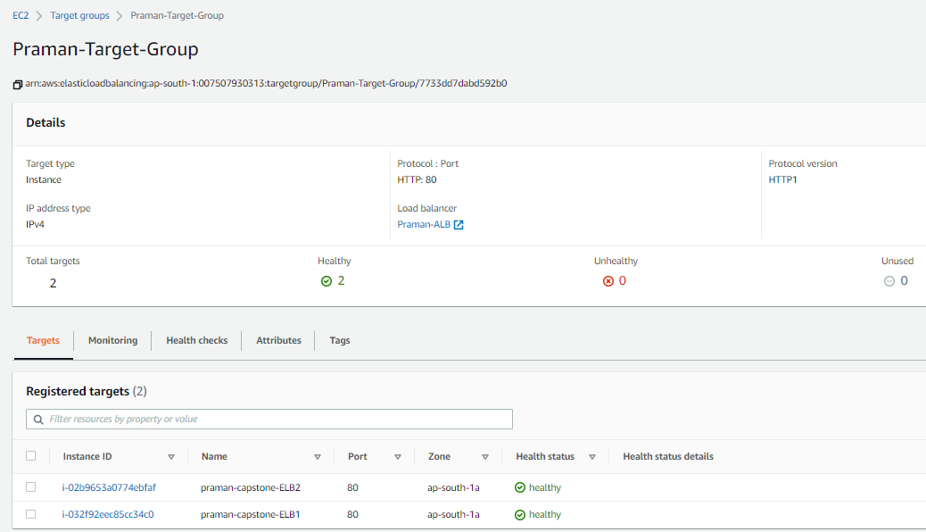

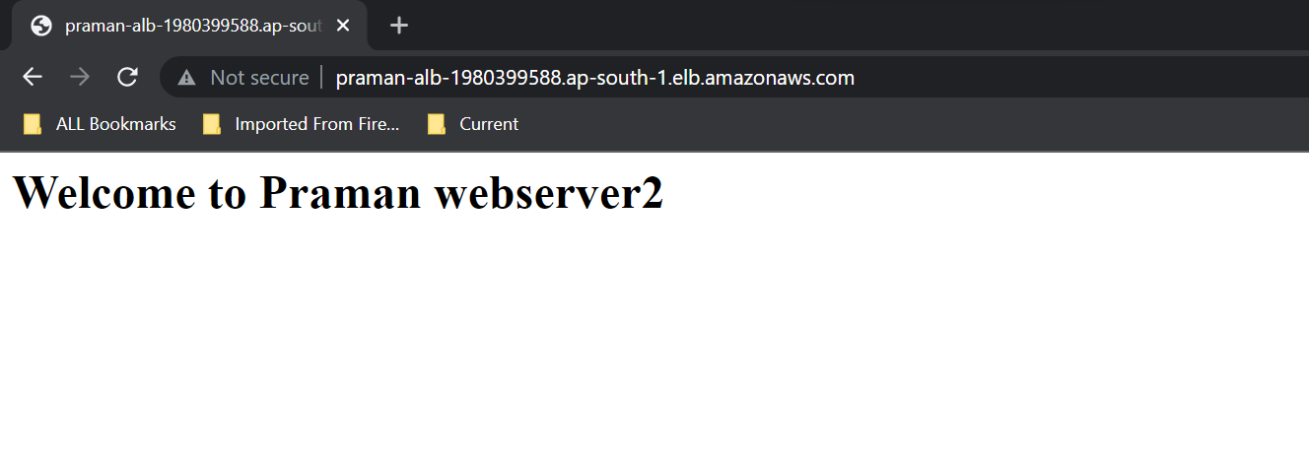

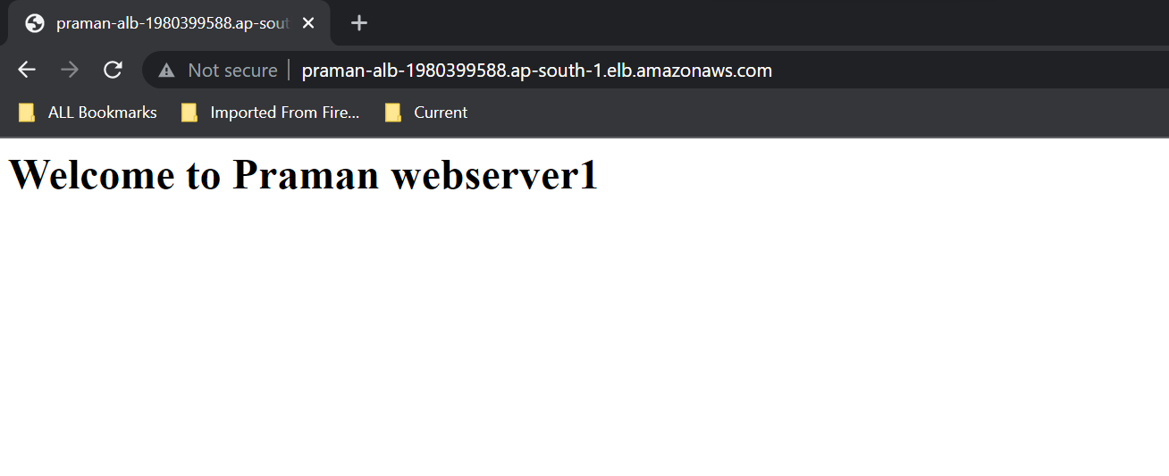

**Task 5 – Delete instances**

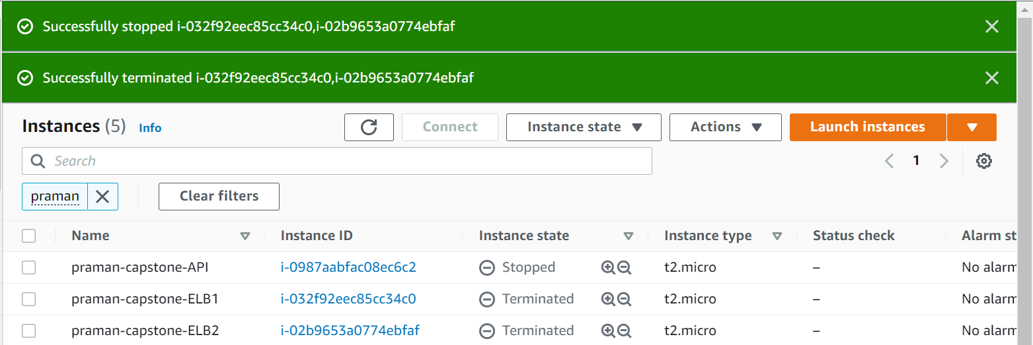

**LAB 2 – AWS ELB and AUTOSCALING**

**Task 1 – Launch Config & ASG**



